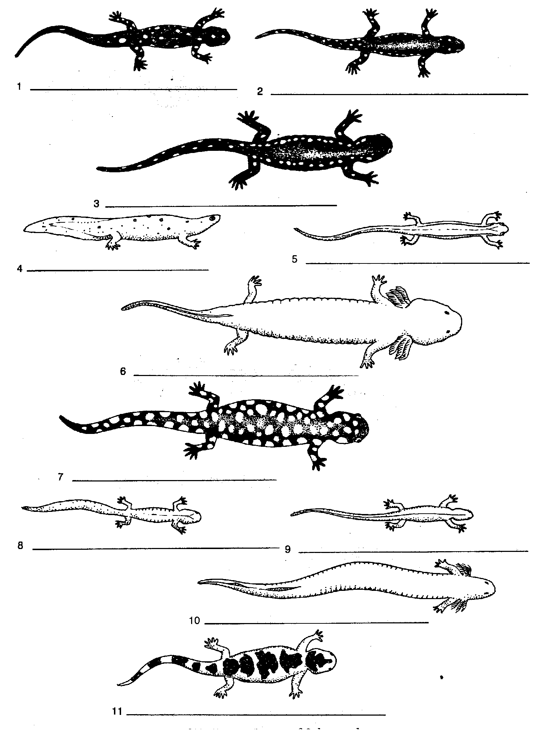

1 | a | Hind limbs absent | Siren
 | b | Hind limbs present | Go to 2
2 | a | External gills present in adults | Mud puppy
 | b | External gills absent in adults | Go to 3
3 | a | Large size (over 7 cm long) | Go to 4
 | b | Small size (under 7 cm long) | Go to 5
4 | a | Body background black, large white spots irregular in shape and size completely covering body & tail | Tiger salamander
 | b | Body background black, small, round, white spots in a row along each side fro eye to tip of tail | Spotted Salamander
5 | a | Body background black with white spots | Go to 6
 | b | Body background light color with dark spots and or lines on body | Go to 7
6 | a | Small white spots on a black background in a row along each side from head to tip of tail | Jefferson salamander
 | b | Small white spots on a scattered throughout a black background from head to tip of tail | Slimy salamander
7 | a | Large irregular black spots on a light background extending from head to tip of tail | Marbled salamander
 | b | No large irregular black spots on a light background | Go to 8
8 | a | Round spots scattered along back and sides of body, tail flattened like a tadpole | Newt
 | b | Without round spots and tail not flattened like a tadpole | Go to 9
9 | a | Two dark lines bordering a broad, light mid-dorsal stripe with a narrow median dark line extending from the head onto the tail | Two-lined salamander
 | b | Without two dark lines running the length of the body | Go to 10
10 | a | A light stripe running the length of the body and bordered by dark pigment extending downward on the sides | Red-backed salamander
 | b | A light stripe extending the length of the body, a marked constriction at the base of the tail | Four-toed salamander

