Name: _____________________________________________

Virtual Earthworm Dissection
Introduction: This is used as a make-up lab or a supplemental lab to the earthworm dissection. Students will access a website where they can read about the structures found in an earthworm dissection and label diagrams.
Website: http://www.mhhe.com/biosci/genbio/virtual_labs/BL_14/BL_14.html

A. Initial Question & Introduction
1. What is the purpose of studying and dissecting an earthworm?
2. To what phylum do earthworms belong? ___Annelida__________ What is their species name? _____Lumbricus Terrestris__________
3. What is a coelom? ______Fluid filled body cavity_______________________
4. What is a hermaphrodite? ___both male and female sex cells________
5. What do earthworms eat? ___plant material found in soil__

B. Click the Lab Manual to read about the external anatomy of the earthworm.
1. How can you tell the dorsal side from the vental side? ___dark and rounded________
2. What are the setae used for? ______anchor in the soil while moving_______
3. Where is the clitellum located and what is it used for? ___dorsal surface near the anterior end used in reproduction___
4. What is the purpose of the excretory openings?__to eliminate waste___

C. Close the Lab Manual and go to the main page. Drag and drop the labels to the picture. Label the picture below.
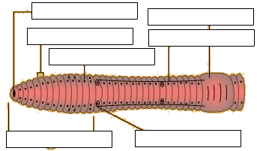
Mouth – clitellum
Segment – sperm groove
Setae
Anterior – sperm duct

D. Click on the "Internal Anatomy" Button and open the lab manual to read about the internal structures.
1. The mouth leads to what structure: _pharynx__________________________
2. Why is the esophagus hidden in the drawing (and on the real earthworm)? __it is under the circulatory system_
3. After the esophagus, food passes through what three structures: _____crop, gizzard, intestine_____________
4. Undigested particles are eliminated through the _______anus________________
5. The ventral nerve cord consists of a chain of ___ganglia_______ and three pairs of _____nerves__________ in each segment.
6. What is the purpose of the nephridium? ___collect and eliminate waste______
.....Where are they located? ___left and right of the digestive tract___
7. What is the purpose of the seminal vesicles? _____where sperm mature______
.....Where are they located? ___________________
8. Where are the seminal receptacles located? __________________________________

E.. Close the Lab Manual and go to the main page to view the internal anatomy picture. Drag and drop the labels to the picture. Label the picture below. Note that not all of the structures are indicated on this picture.

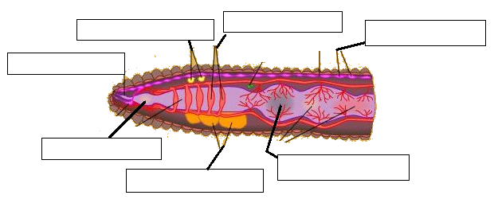
F. Click on the "Journal" button. You will be given a series of questions to answer. Answer them on this sheet instead. You can reference the lab manual to help you answer the questions.
1. What part of the digestive system would you see in a cross-section anterior to the gizzard? Crop
2. What structure in the earthworm has a similar function as the human heart? Explain your answer.
3. What do two earthworms exchange during mating? Explain your answer.
4. Describe the difference between a closed and an open circulatory system.
5. Do earthworms have a front and a back end? Explain your answer.
6. What characteristics distinguish an annelid from other worms?

