Name:________________ Per:__________
Metric System Notes Day 1

- Neutral and _________________
  - Language understood around the _______________
- Common Prefixes
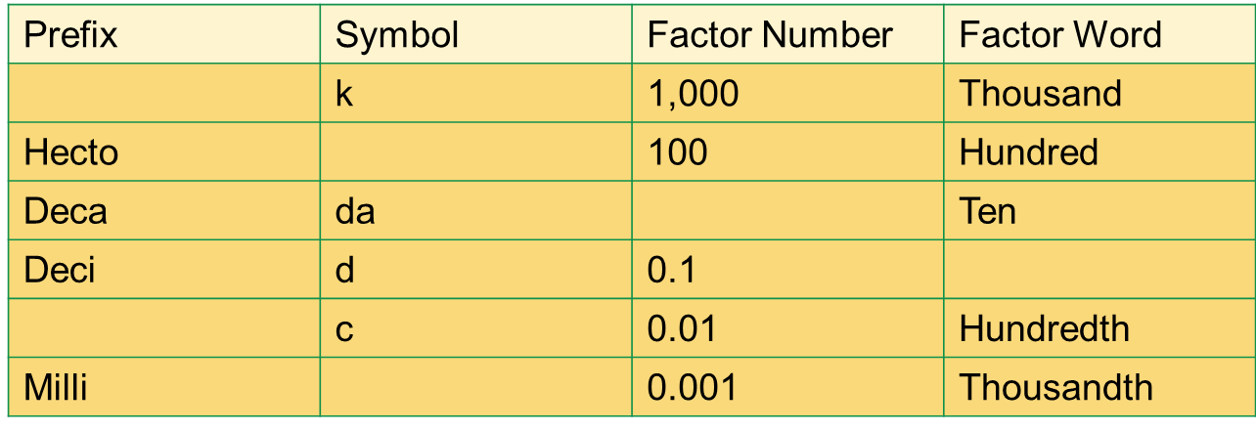
  - No ___________ = 1

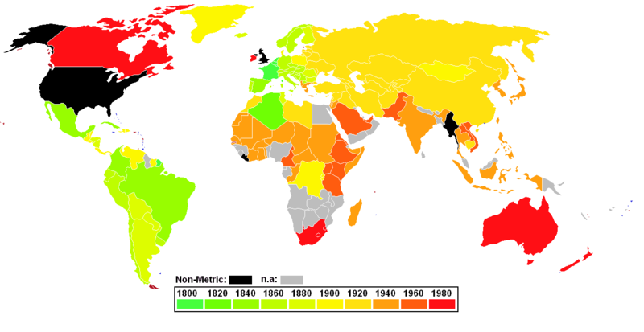

- Measuring Length
  - When reading a ________________________ we use Centimeters and Millimeters.
    - _______________ = 0.01 (one-hundredth of a meter)
    - _______________ = 0.001 (one-Thousandth of a meter)
    - – _________ Centimeters in a Meter
    - – _________ Millimeters in a Meter
Write down the measurements for the arrows as practice.

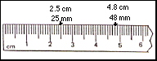

Metric System Notes Mass Day 2

- The unit used to weigh objects in the Metric System is based on the ________________.

  - The most commonly used units are the ______________, the ________________, and the __________________.

    - 1 gram (g) = _____________ milligrams (mg)
    - 1 kilogram (kg) = _____________ grams (g)
    - How many mg are in a kg? ________________

- References for a gram
  - A gram can be equal to a:
    - Pen cap on a plastic Bic pen
    - _________________
    - Single Smartie candy
    - _________________
  - A brand new US nickel will have a mass of _____________

- Scientific Notation
  - Used to save space when dealing with extremely large or extremely small numbers
  - Rules for writing in Scientific Notation
    - Must be 1 digit to the left of the decimal
    - If you move the decimal to the __________ = 10x to the negative
    - If you move the decimal to the __________ = 10x to the positive
Metric System Notes Volume Day 3

- Metric Volume is based off the __________ for liquids and ____________________ for solids

  - 1 ______ = 1 ________
  - 1 L = 0.001 cubic meters
  - 1 kiloliter = 1 ________

- Reading Volume
  - Liquids will for a ___________ in a graduated cylinder
  - The volume is measured from the bottom of the meniscus

- Volume Displacement
  - A solid object will _________ an amount of water __________ to its _____________
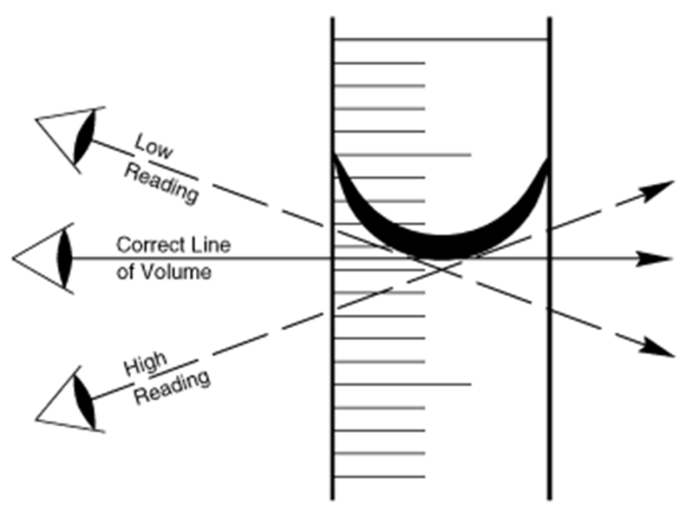

How much liquid is in this cylinder? _______________
How many mL are in this graduated cylinder? ______________

